**Create a simple cloud software application for Library book reservation system for SIMATS library using any Cloud Service Provider to demonstrate SaaS include the necessary fields such as Title of the book, author, publications, Year, edition, no of copies, Rack no, status (taken/returned) etc.**

**AIM:**

To Create a simple cloud software application for Library book reservation system for SIMATS library using any Cloud Service Provider.

**PROCEDURE:**

**STEP 1:**

Open browser and get into zoho ceator. Then sign in and click “Create application”. Below given screenshot will appear, hear type the application name of your Aim.

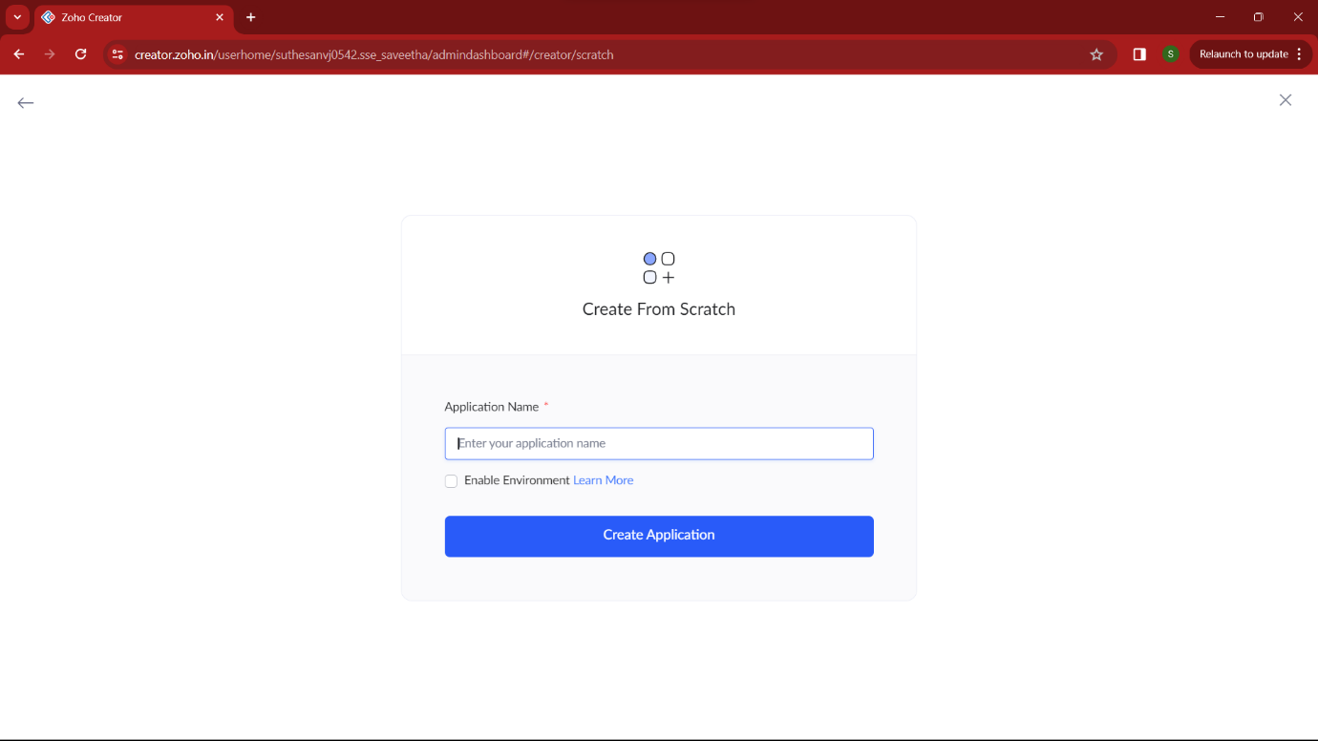

**STEP 2:**

Then select “start from scratch” option and select the proper component from the 4 components listed. For my application I just selected “forms” for the login credentials.

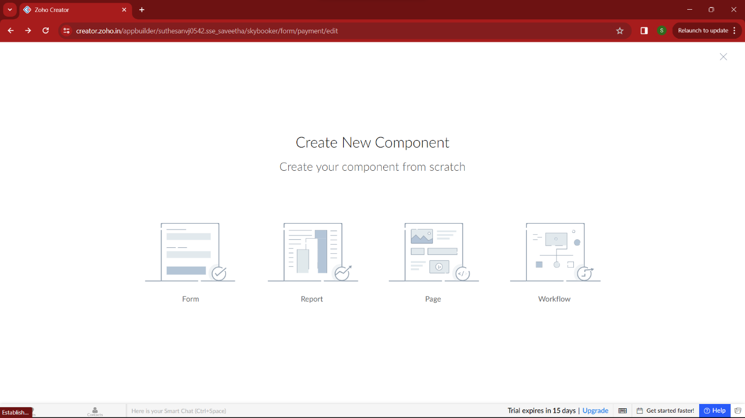

**STEP 3:**

In forms, below given options will be given. From here we can get sample templates of our requirements, otherwise we can import already saved schema for our application. I just selected “ from scratch” option for my application.

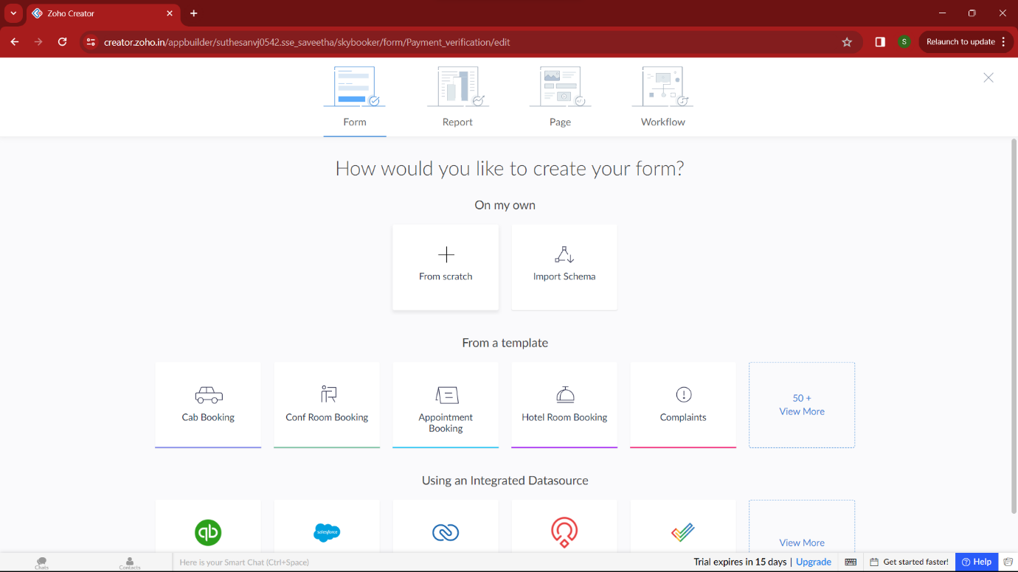

**STEP 4:**

Then provide an appropriate name for our application in the name form which shown below. I gave “CampusReads” for my “Library book reservation system”

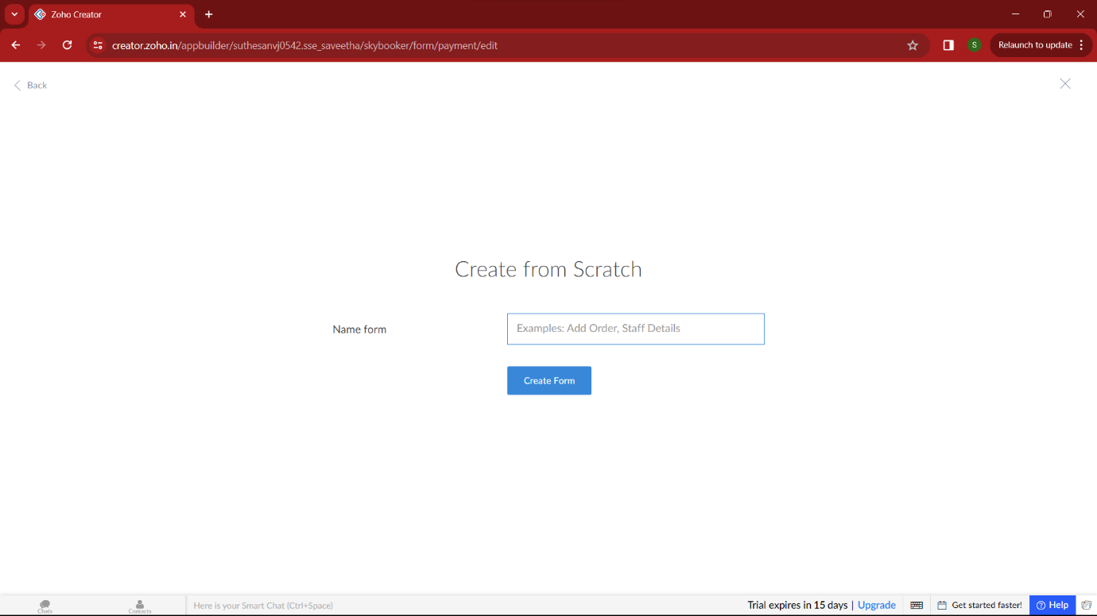

**STEP 5:**

by clicking “+” symbol shown in the picture given below, we can add number of forms in our application. Firstly I placed login form in my application with the essential credent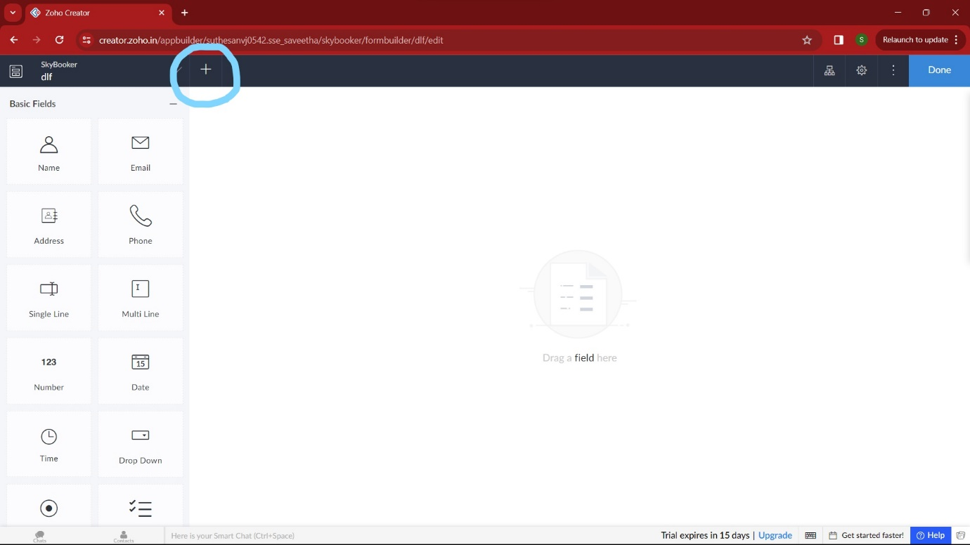

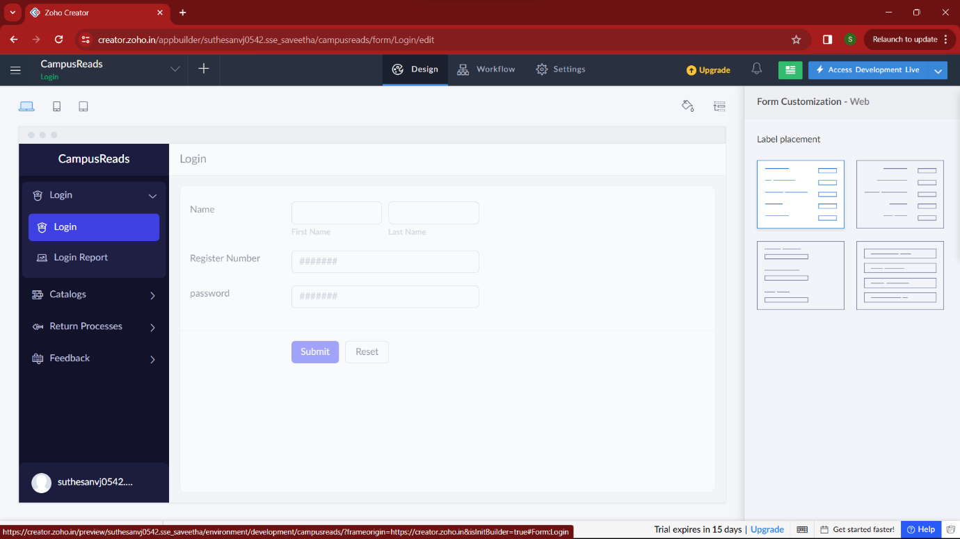

**STEP 7:**

Then I added another form namely “Catalogs”. It gets the required datas from the user, and checks the availability of the book.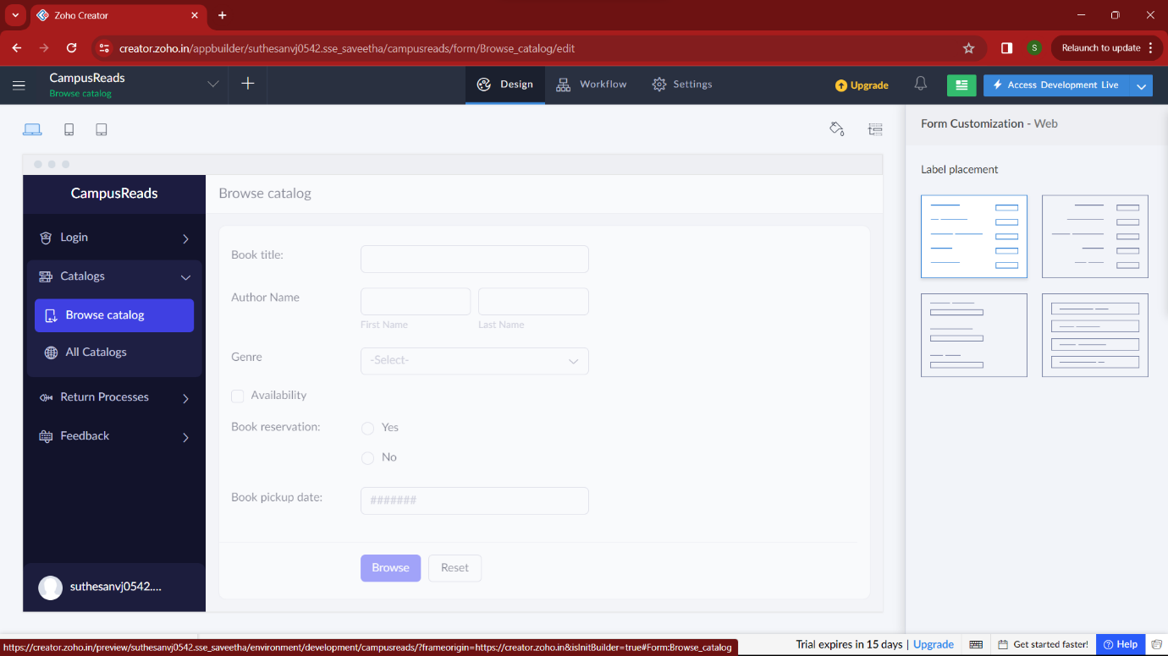

**STEP 8:**

Then I added another form namely “Return type” which shows the fine amount and return date of the book. 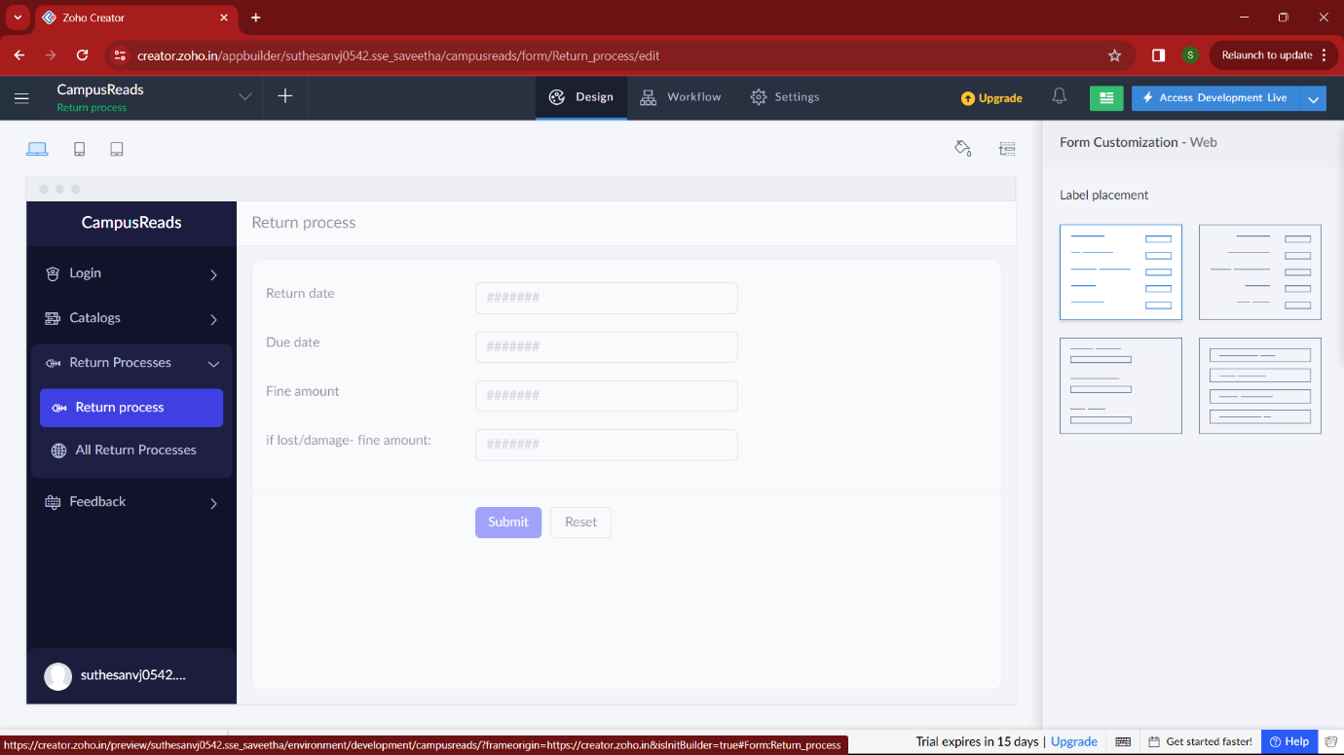

**STEP 9:**

Then in the next form I added “feedback” of this service. Here user can give their feedback on these process.. 